**CSE5335: Web Data Management (Fall 2018)**

**Project # 2 (Chapter 3)**

For this assignment, you have the following task

1. Create a new folder for the PetStore
2. Create an external style sheet named pet.css that configures the color and text for the PetStore website
3. Modify the Home Page to utilize an external style sheet to configure colors and text

Colors #666666 ( for the text), #FFFFFF( for the background), #000033 ( for the header text background)

Font: Verdana, Arial or any sans-serif font.

Style for the h1: 200% line height

Style for the h2: color: #3399CC; font-family: Georgia, serif

Style for the nav element, bold text, #90C7E3 ( for the nav background);

Styles for the footer element selector that configure background color, font size ( .70 em) italics and centered text.

Configure index.html and aboutus.html content that is centered 80% width (use a style rule with id named wrapper)

**Compress your folder and submit it.**

**Do not email me the assignment**

index.html

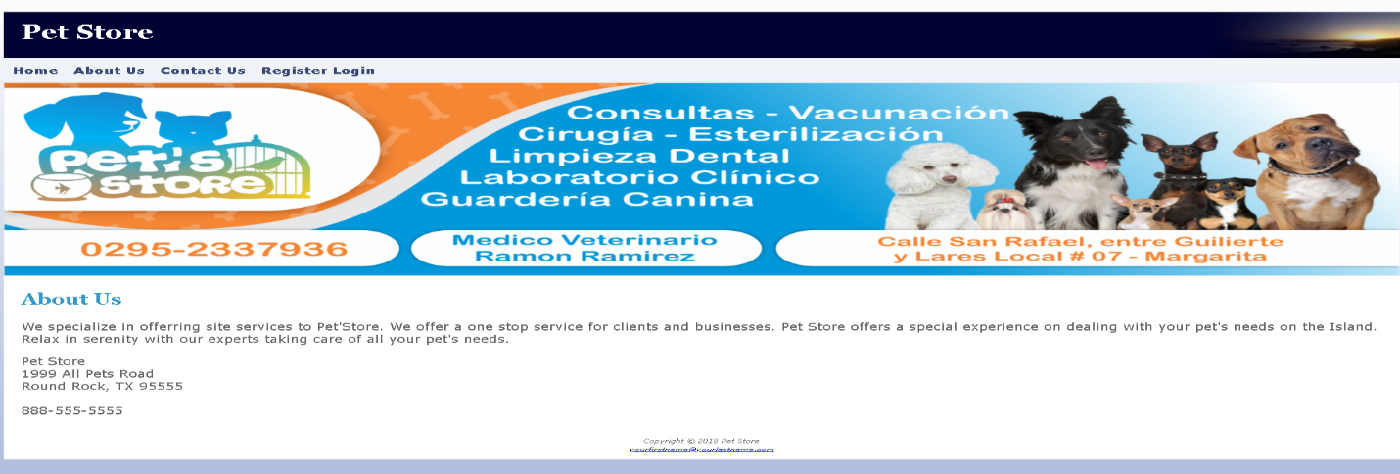

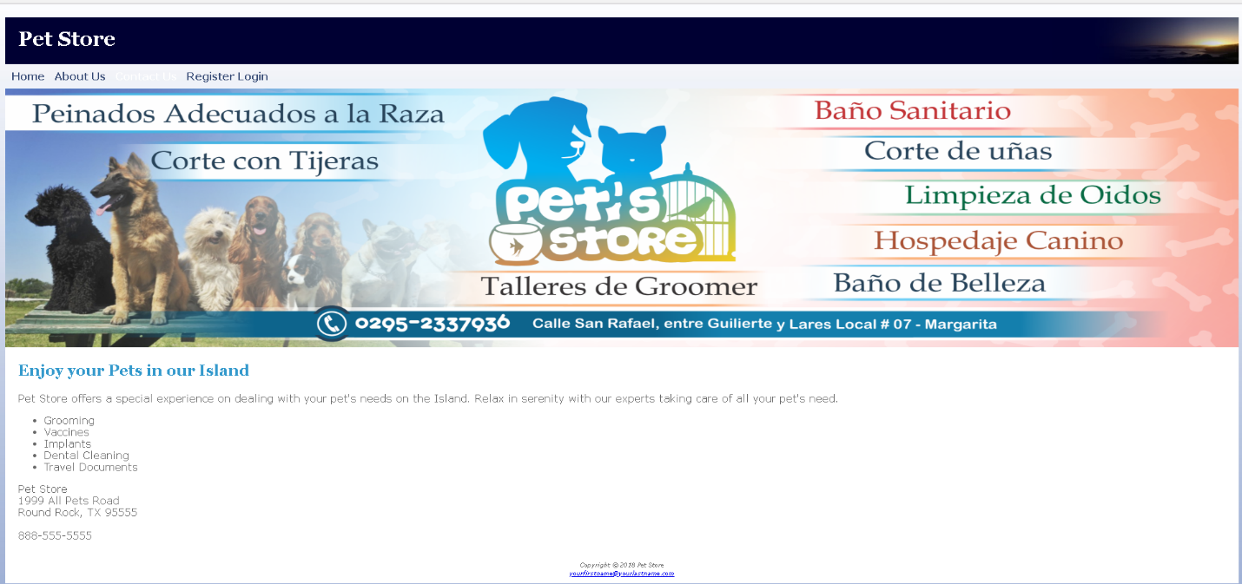

**Project # 3**

This assignment will cover several chapters (5,6,7,8)

For this assignment, you have the following task

1. Create a new folder for the Petstore
2. Modify the HomePage to implement the two-column page layout
3. Modify the pet.css to configure the two-column page layout
4. Modify the about page to use a table
5. Save your folder as yourname_assignment3
6. Include in your folder all the pages of the project. Compress and submit.
7. Make sure that you page shows responsive web design. It should show configurations in the CSS for Desktop, Tablets and Smartphones

**Submitting only screenshots of the project will give a grade of 0.**

1. Use same colors as in previous projects.
2. For the table use:

1) table is centered

2) takes up 90% of the container

3) 0 border spacing

4) background color in alternate rows use a class of the nth of type pseudo class to configure odd table rows.

Colors #666666 (for the text), #FFFFFF (for the background), #000033 (for the header text background)

Font: Verdana, Arial or any sans-serif font.

Style for the h1: 200%-line height

Style for the h2: color: #3399CC; font-family: Georgia, serif

Style for the nav element, bold text, #90C7E3 (for the nav background);

Styles for the footer element selector that configure background color, font size ( .70 em) italics and centered text.

Configure index.html and about.html content that is centered 80% width (use a style rule with id named wrapper)

index.html

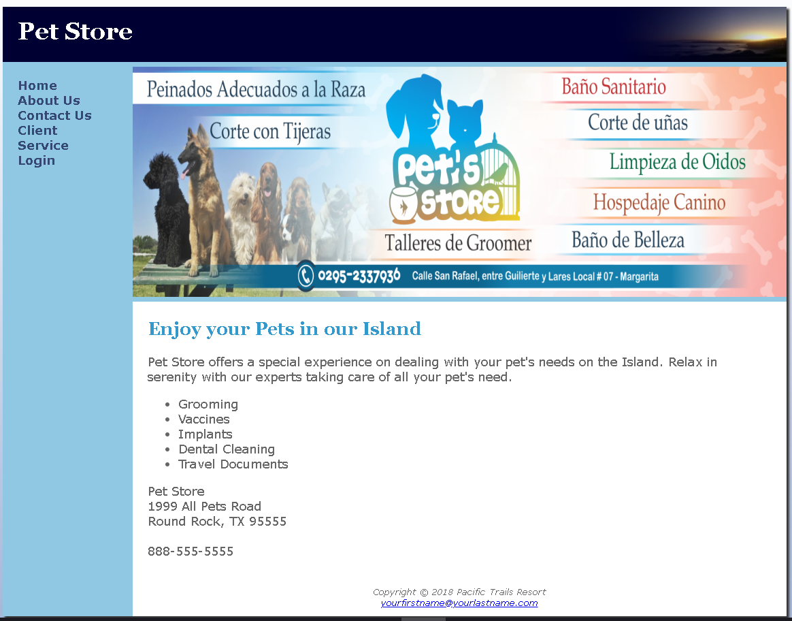

About.html

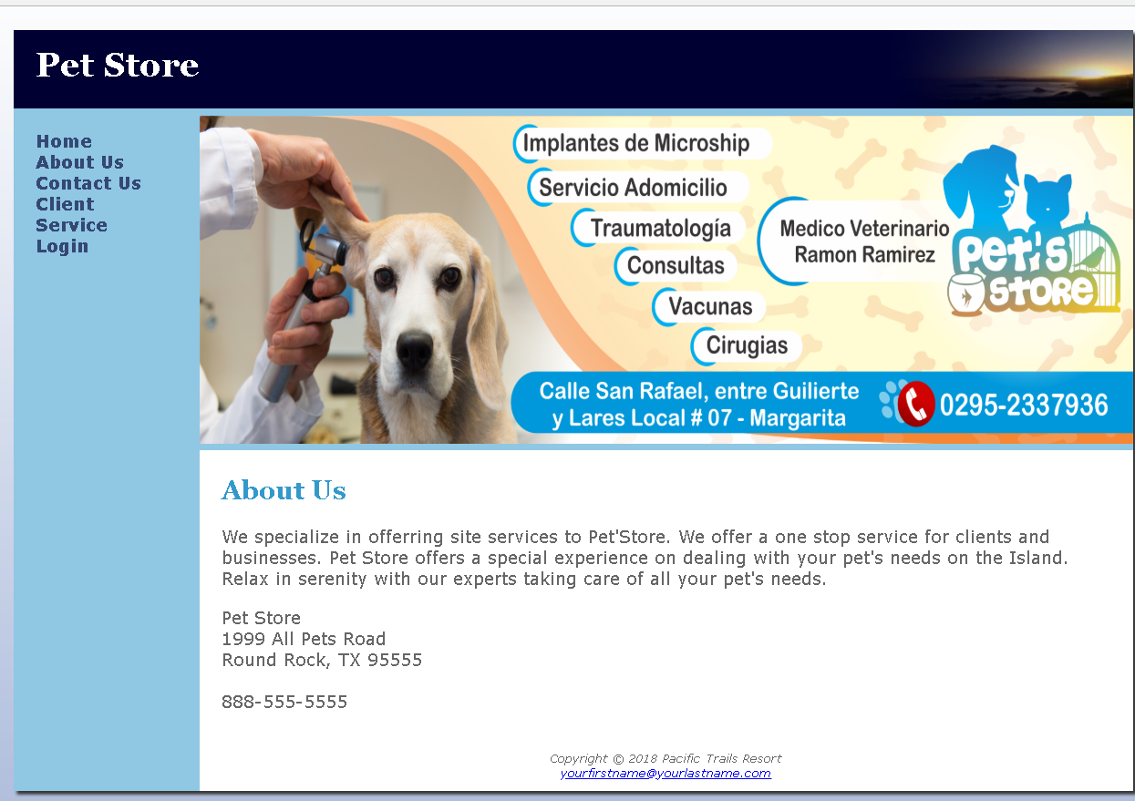

**Project # 4**

**This project is to create a form, validate fields and connect to the database.**

For this assignment, you have the following task

1. Create a new folder for the Pet
2. Modify the style sheet (pet.css) to configure style rules for the new css.

Create the new form pages (contact) , client,service,login,client login, business login

Create the Client.html and service.html

1. Configure HTML5 form controls.
2. Do the corresponding Database connection, show your Database
3. Provide screenshots of testing
4. Place all your pages in your folder. Compress it and Submit.

**All fields in the form should be validated on the client side and server side.**

Colors #666666 ( for the text), #FFFFFF( for the background), #000033 ( for the header text background)

Font: Verdana, Arial or any sans-serif font.

Style for the h1: 200% line height

Style for the h2: color: #3399CC; font-family: Georgia, serif

Style for the nav element, bold text, #90C7E3 ( for the nav background);

Styles for the footer element selector that configure background color, font size ( .70 em) italics and centered text.

Configure pages to be centered 80% width (use a style rule with id named wrapper) The main goal of this project is to learn server-side web programming using PHP and a relational database system (MySQL). More specifically, you will develop a web application where customers can buy from this site and businesses can offer their services. The Login

## Platform

As in the previous projects, you will develop this project on your PC/laptop using XAMPP.

Download the project4 files: project4.zip from UTA Blackboard. Unarchive the files inside your web server document root directory.

To create the database, start the Apache Web Server and the MySQL Database on your PC using the XAMPP manager console. Run [phpMyAdmin](http://localhost/phpmyadmin/) on your browser, create a new database with name pet clicking on New. Select this database, go to the SQL tab and write the appropriate CREATE table queries and push Go. You can run queries from CreateDB.sql for testing.

**Requirements ( I am helping with the DB, check it out)**

Create your database using phpMyAdmin based on the following schema:

client (userid, fname,lname, phone,email) *info about a Client*

client (userid, ,serviceid) *info about a Client*

user (userid,password,email,roleid) *info about a user*

business(bussid,bname) info about the business

businesservice(bussid,,userid,serviceid) info about the business

service (serviceid,service_description)

role(roleid,descripticon) 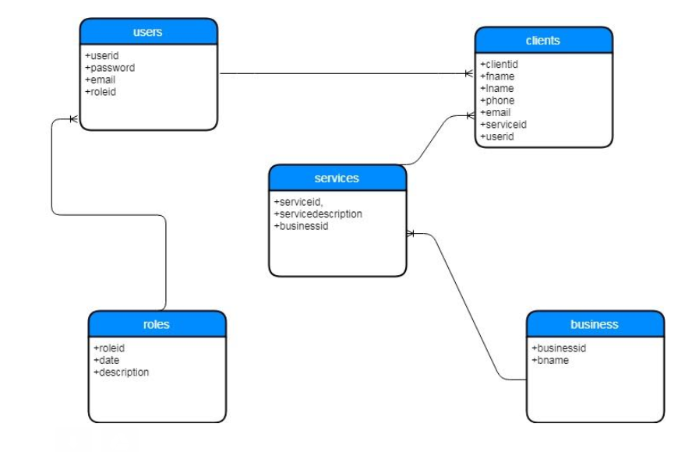

In this schema, foreign keys have the same name as the primary keys they reference. Insert some data into the tables. Each table should contain at least four rows. Try to write your data in such way that you can get meaningful answers for various queries.

## Project Requirements

Your script mypet.php must be able to show data related to the services requested by a customer and provided by a business

. Data will be coming from the DB.

index.html

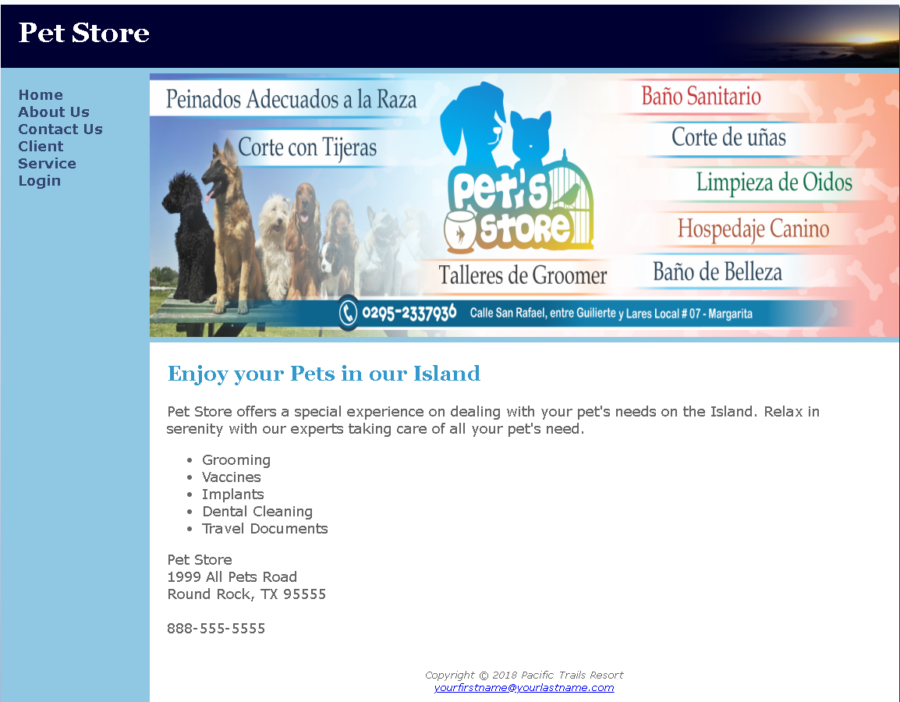

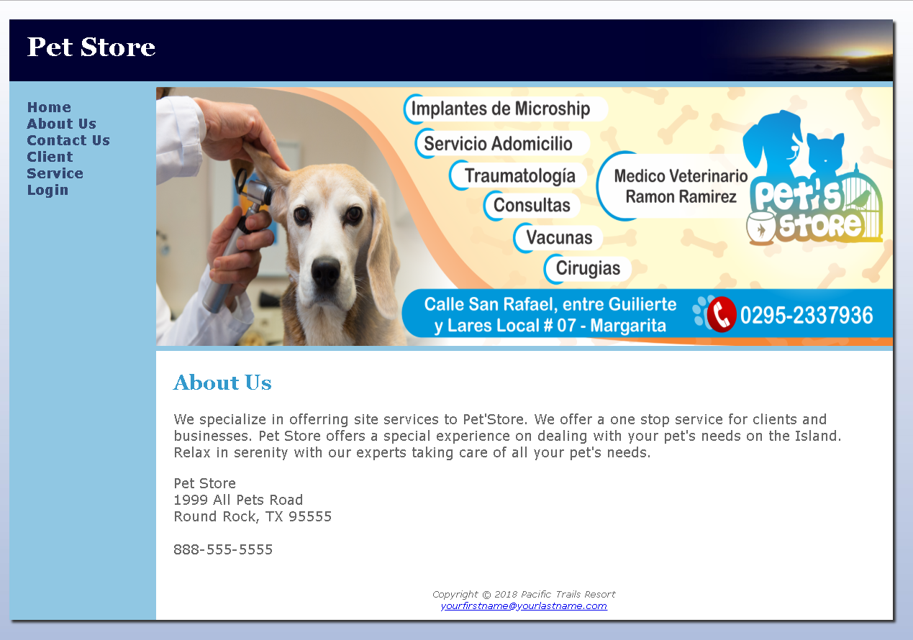

About Us

Contact Us

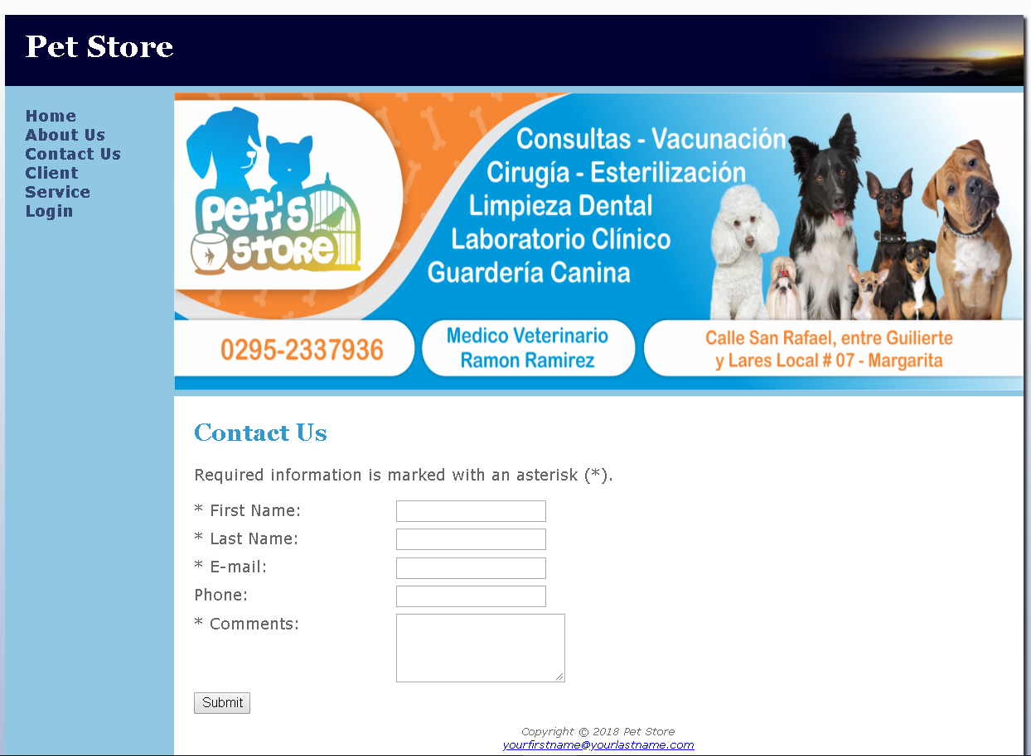

Client

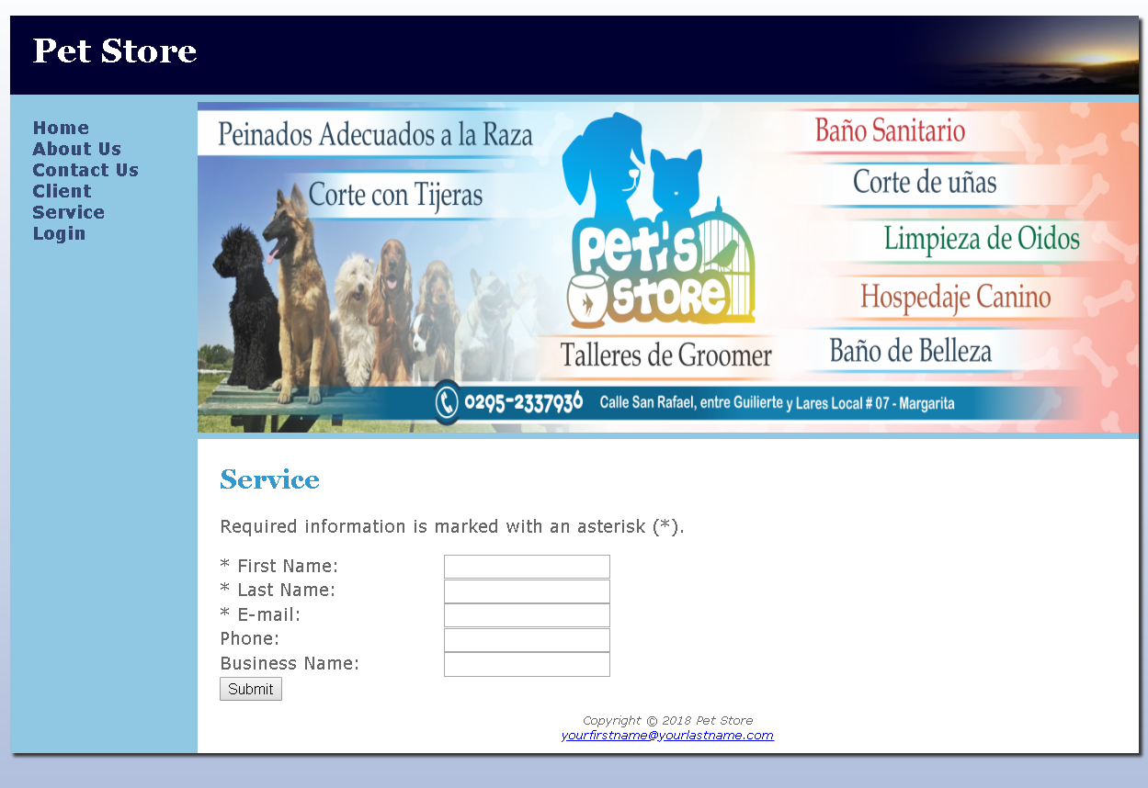

Service

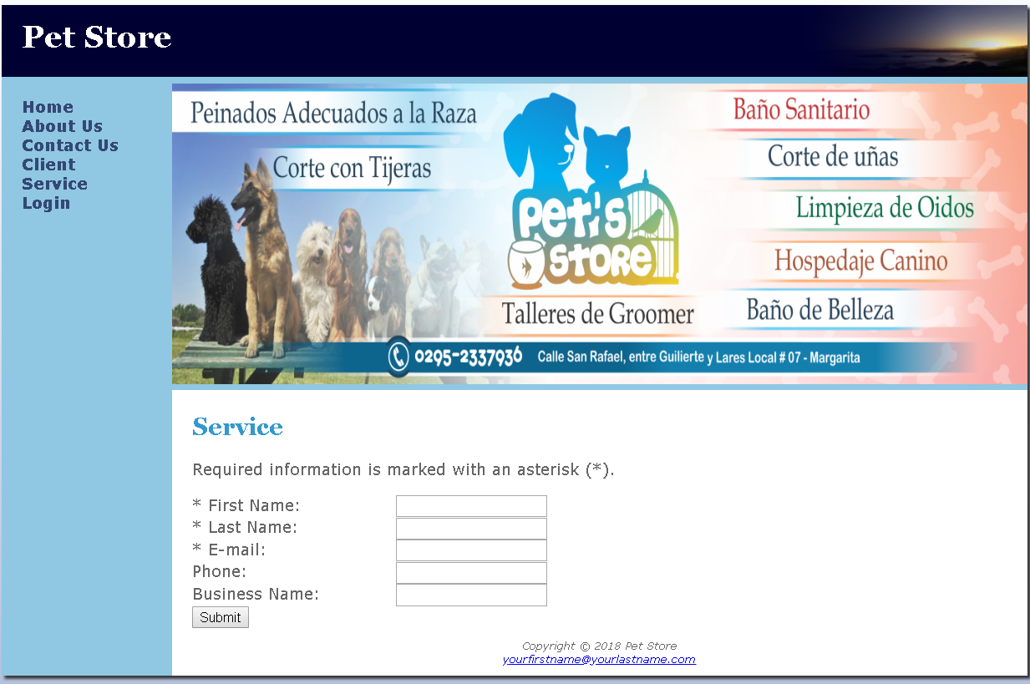

Login.html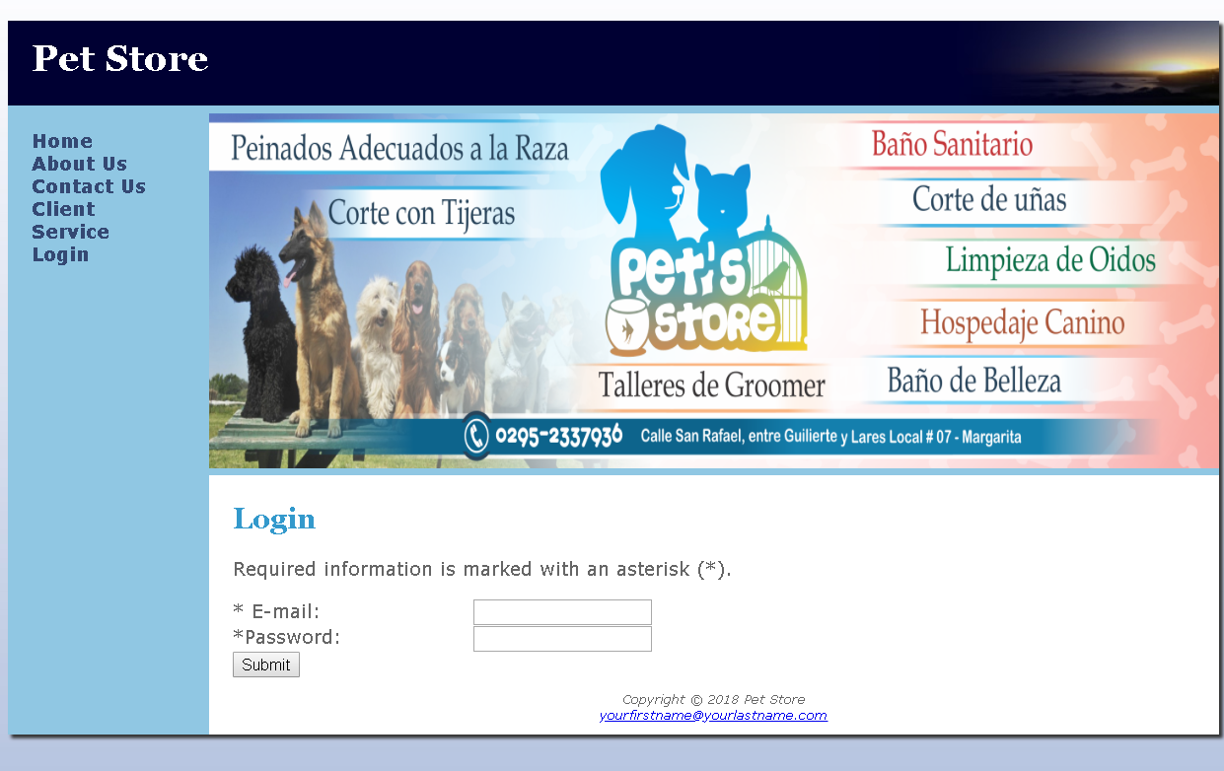

**Login Business**

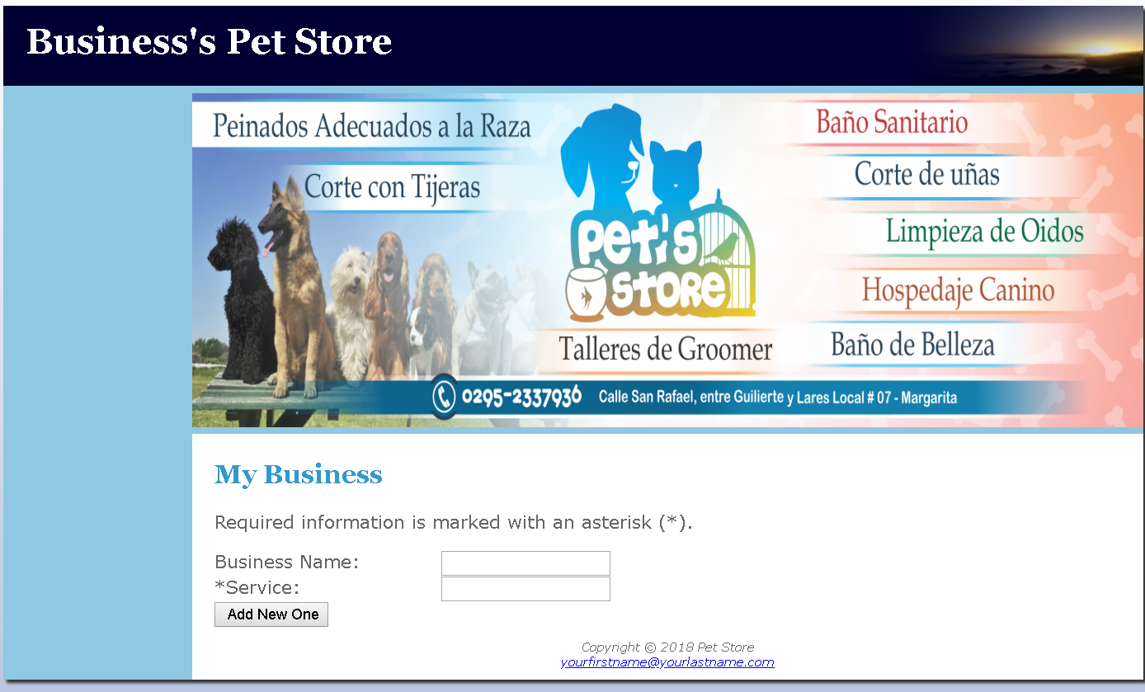

**Login Client**

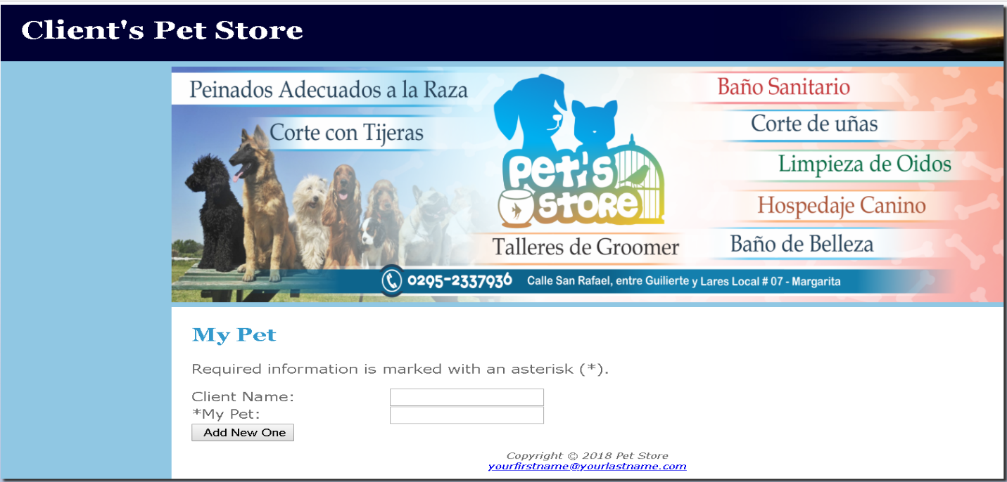

**Project # 5**

**This project is the same as project 4 but it uses CodeIgniter Framework**